**First level.**

Display the information from the Shopping_List table (created earlier) about the most expensive and cheapest product. Execute the query using the SELECT command:

* column Price from table Shopping_List

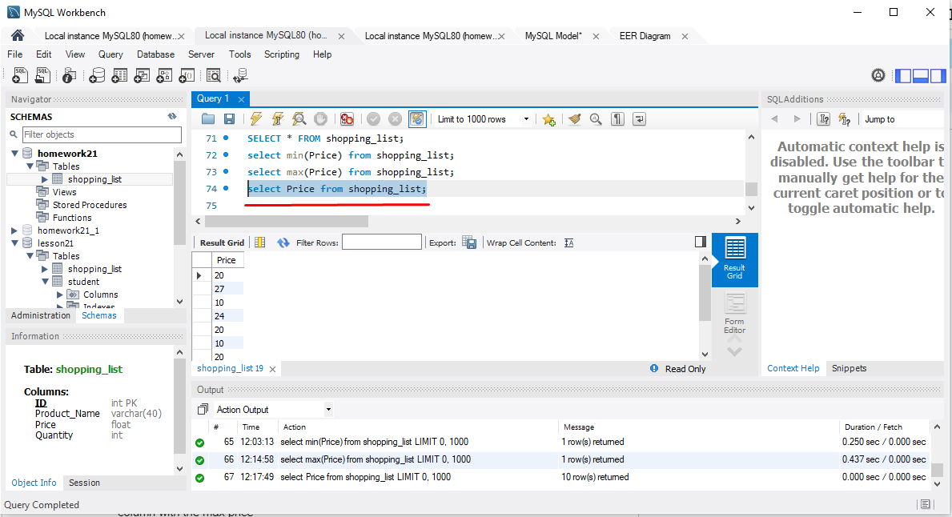

* column with the minimum Price

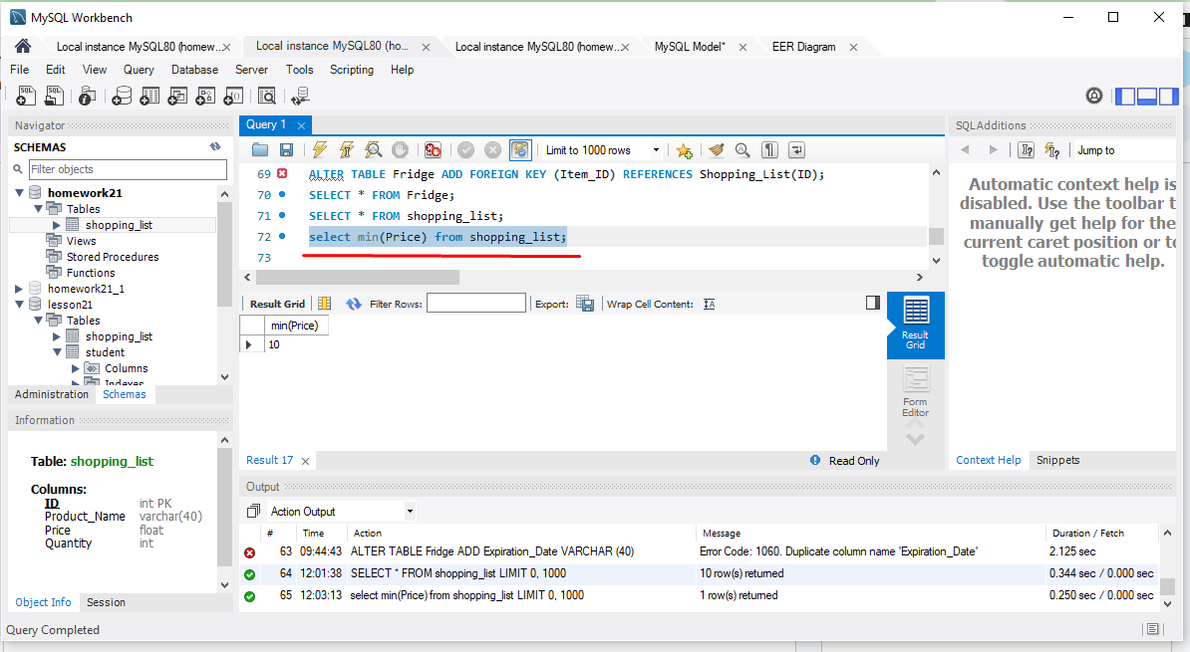

* column with the max Price

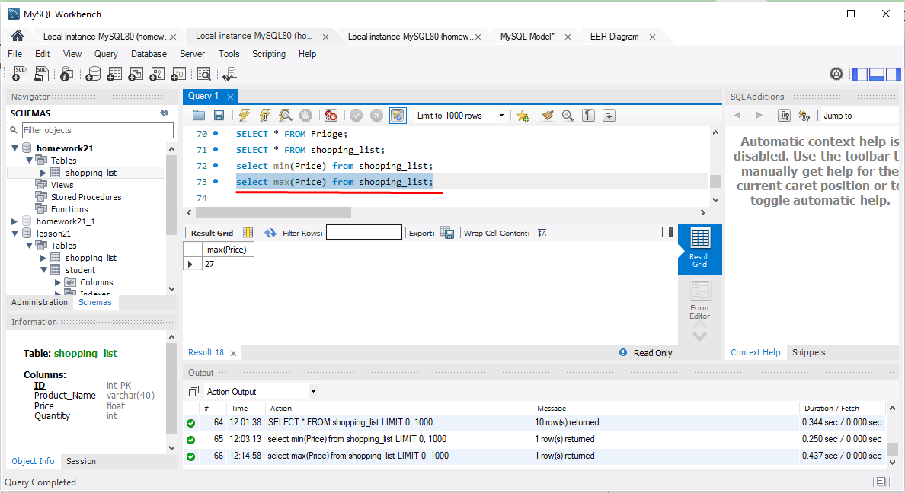

* column with the AVG Price

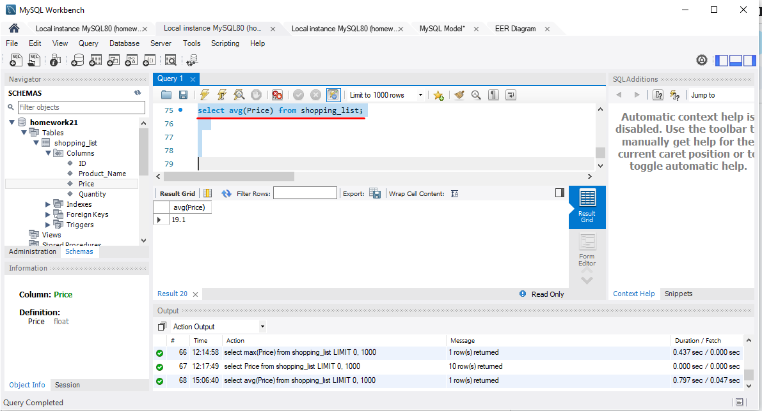

**Second task.**

Total number of products in the Shopping_List table:

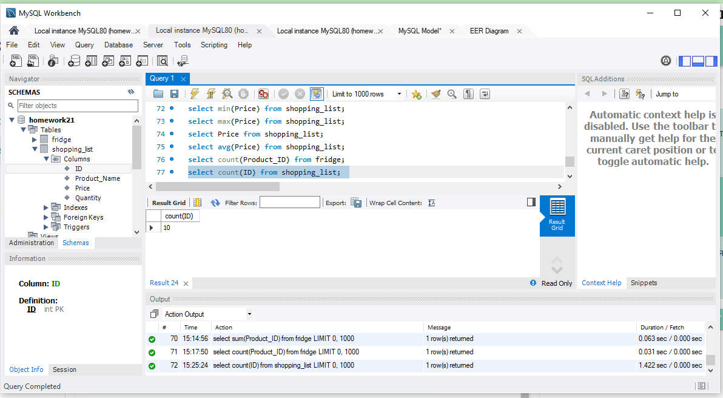

The total number of all products in the Fridge table:

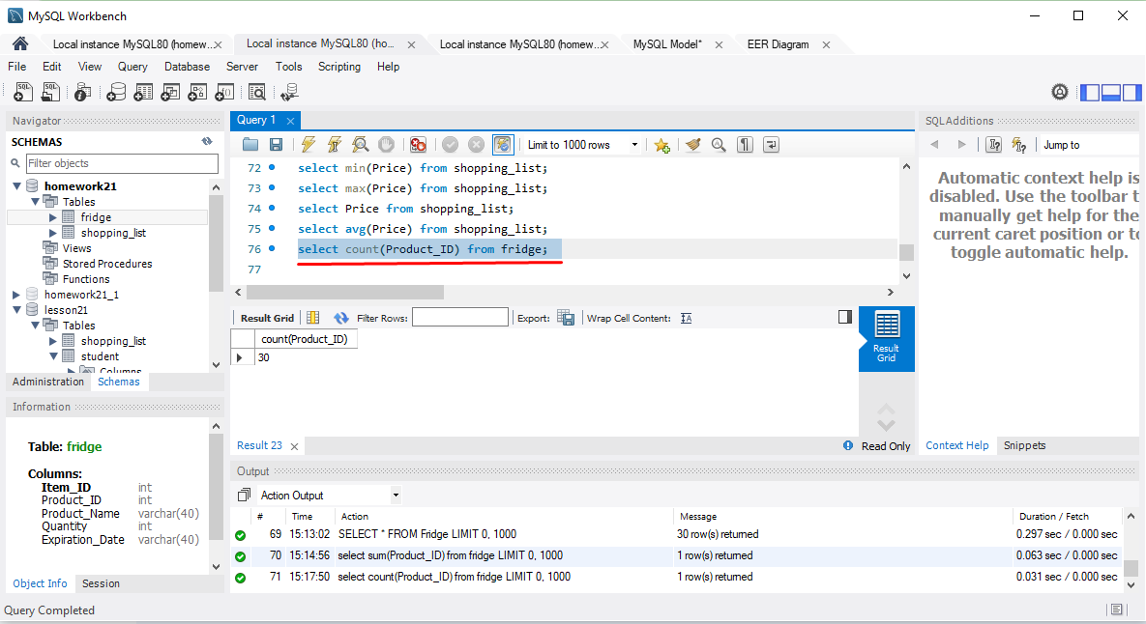

**Third task.**

Number of products and their names in the fridge tables:

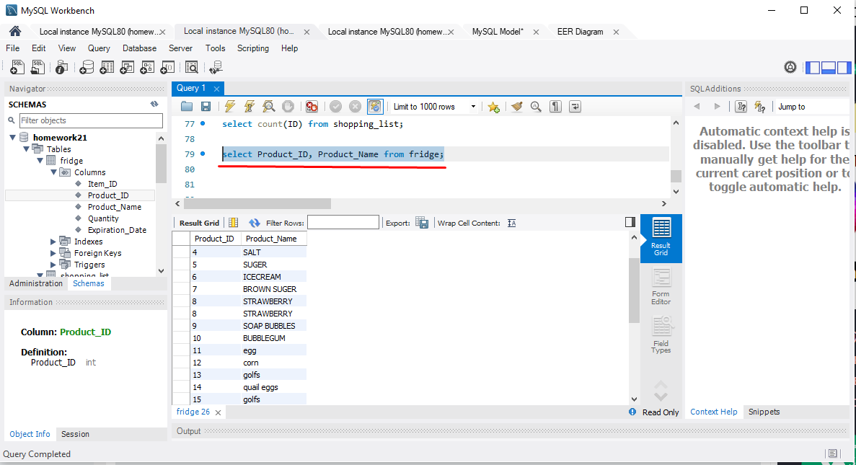

Group the two columns of the fridge table by expiration date:

